**CS449- Human Computer Interaction-**

**Assignment-3 Cognitive Modeling in HCI**

**Zeki Karamuk 22496**

This report aims to compare the efficiency of playing a song and adding it to a new playlist on the Spotify and YouTube Music mobile apps using CogTool. This project's objective is to use the mobile device's keyboard and screen to look for the band Alice in Chains. After that, locate and play the song "Rotten Apple" from the album "Jar of Flies." Finally, make a new playlist called "Test" and add the song to the newly created Test album. To perform this analysis and objective, the designs of both apps were implemented in CogTool, and playing a track and adding to playlist task was simulated on these designs.

1. **Which playing music procedure is faster, Spotify or YouTube Music?**

As can be seen in figure 1 and CogTool's statistics, YouTube Music performed the playing a track task in 18.9s and spotify preformed the same task in 19.1s. And this shows that YouTube Music’s playing music procedure is slightly better than Spotify.



*Figure 1: Total times needed*

1. **Why is the faster procedure faster?**

Youtube Music performed the task faster because its reccommendations were better and app uses less transformation between screens which decreases the user's cognitive load and physical effort. By looking at the search process and playlist creation processes the question why the Youtube Music performed better than Spotify in same task could be answered.

1. Search and Result Process

During the search phase, Spotify efficiently completed the song group Alice in Chains search process in 8.526 seconds. However, the band "Alice in Chains" was ranked fifth in the reccommendations list of the following search results. As a consequence, the user had to read four other suggestions before he/she could select the correct one. And this added extra "look-at" and "cognition" steps to search process, which also extend the total duration.

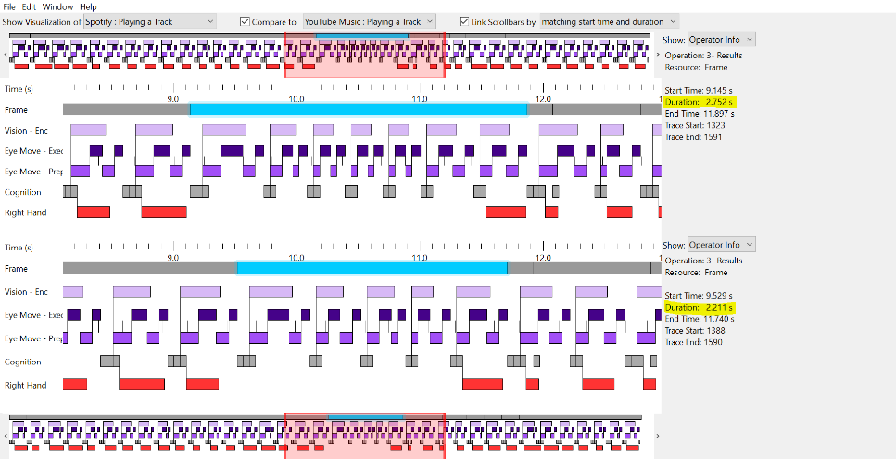In contrast, YouTube Music has more optimized results where the target option is displayed more prominently. Becuase of that user selected desired option faster and reduced the number of "look-at" steps and minimized cognitive load. Optimization of the reccommendation list resulted with decreasing overall execution time, reducing look at time and minimizing the cognitive load. This scenerio aligns with Benyon (2019) discusses in "Visual Interface Design and Psychology," efficient search mechanisms and user-friendly interfaces significantly reduce cognitive load and task execution time.

*Figure 2: Results Process Visualization*

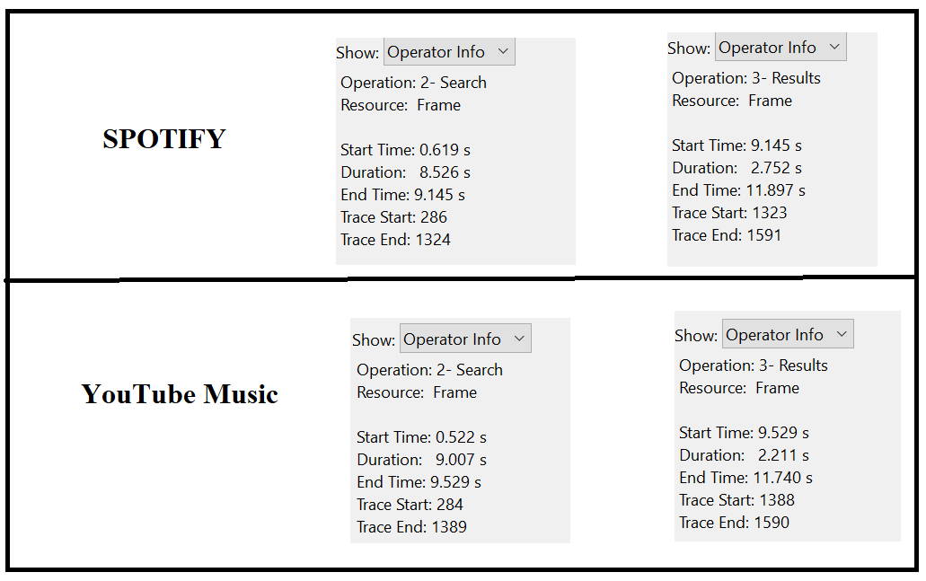In figure 3, the duration of search process and selection of desired band from the reccommendations list process are shown. As can be seen, Spoitfy completes search process in 8.526 seconds and Youtube Music completes same process in 9.007 seconds. So spotify search process is 0.481 seconds faster than Youtube Music. (9.007s – 8.526s = 0.481s). But as can be seen in figure 3, Spotify completes result process in 2.752 seconds and YoutubeMusic completes the same process in 2.211 seconds. So Youtube Music’s selection process is 0.541 seconds faster than Spotify. (2.752s - 2.211s = 0.541s) This is because as mentioned earlier Youtube Music’s optimized reccommendation list and layout. which aligns with findings on reducing cognitive load through effective visual interface design (Benyon, 2019; Card, Moran, & Newell, 2008).

*Figure 3: Total Durations of search and select processes*

Despite Spotify's strong search input performance, our investigation shows that its recommendation display results in a longer selection time. The task is completed more quickly overall since YouTube Music's more structured results make the choosing process simpler.

1. Creation of playlist and song add Process

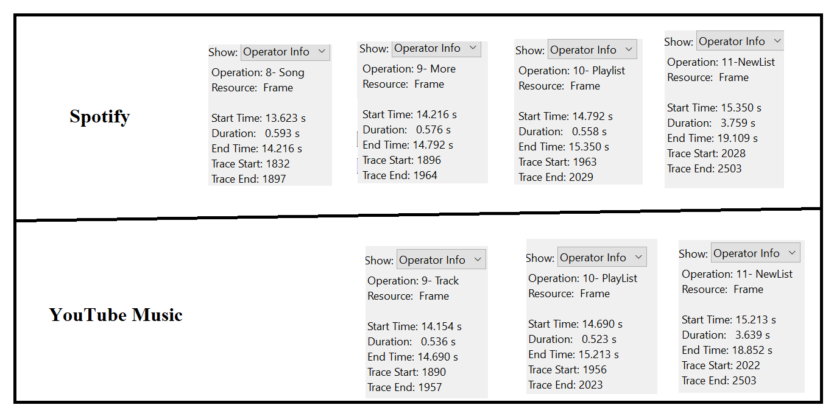After the search process there is a total time difference during the phases that include creating a new playlist titled "Test" and adding a song to this list. As can be seen in the figure 4, Spotify utilizes four pages (pages Song, More, Playlist and NewList) resulting in a total task duration of 5.486 seconds (0.593s + 0.576s + 0.558s + 3.759s = 5.486s). In contrast, YouTube Music accomplishes the same task using only three pages (pages Track, playList and NewList) with a cumulative duration of 4.698 seconds (0.536s + 0.523s + 3.639s =4.698s). So as a result Youtube music has less pages than spotify. While completing the task there is less page transitions are done and total time to complete the task is less in Youtube Music than spotify. This reduction in the number of page significantly contributes to the efficiency of YouTube Music's process. As Benyon (2019) highlights in "Memory and Attention," fewer page transitions mean fewer cognitive shifts, reducing the overall user workload. By using fewer pages, YouTube Music minimizes user interactions and cognitive load and inreases the speed of task.

*Figure 4 : Total Durations of playlist creation*

The analysis and figures highlights that user needs fewer pages needed in Youtube Music mobile app to accomplish the specified task than Spotify. By using fewer pages, fewer page transitions needed which reduces user interactions and minimizes both cognitive and physical workload and also increasing the task speed. In contrast, Spotify need additional pages which causes additional page transitions, more interactions, longer task times, and increase cognitive effort. Additionally, YouTube music interactions are simple and direct which aligns with effective use of Short-Term Memory and reduce cognitive demands compared to Spotify’s segmented approach (Benyon, 2019; Card et al., 2008). As a result, YouTube Music presents more simplifed structure than Spotify and uses fewer pages that needs fewer page transitions by this approach platform decreases cognitive load, reduces user effort, increases user experience and decrease the task completition time.

1. **How can you make the slower procedure faster? How much time can a user save with this change?**

With little changes Spotifies procedure can be faster. As mentioned above Spotify has a good searching timing but reccommendation list was time consuming. If we optimize the recommendation layout we can reduce cognitive load and selection time and save around 0.541 seconds. To optimize this layout, we can put the most relevant results at the beggining of the reccommendation list so that user do not loss time while finding desired choice and reduces total time. Additionally we can decrease the total time if we reduce the page transitions which are used when creating a new playlist from four page structure to a simpler and fewer pages like YouTube Music structure. By that way we could save approximately 0.788 seconds. All together, total time savings of 1.3 seconds, enhancing user experience by reducing cognitive effort and interaction time.

1. References

* Benyon, D. (2019). Visual interface design. In *Designing user experience: A guide to HCI, UX, and Interaction Design* (4th ed., pp. 288-318). Pearson.
* Benyon, D. (2019). Memory and attention. In *Designing user experience: A guide to HCI, UX, and Interaction Design* (4th ed., pp. 505-525). Pearson.
* Card, S. K., Moran, T. P., & Newell, A. (2008). In *The psychology of human-computer interaction* (pp. 23–44). CRC Press.